**DIGITAL VACCINE PASSPORTS SAFETY OR TYRANNY?**

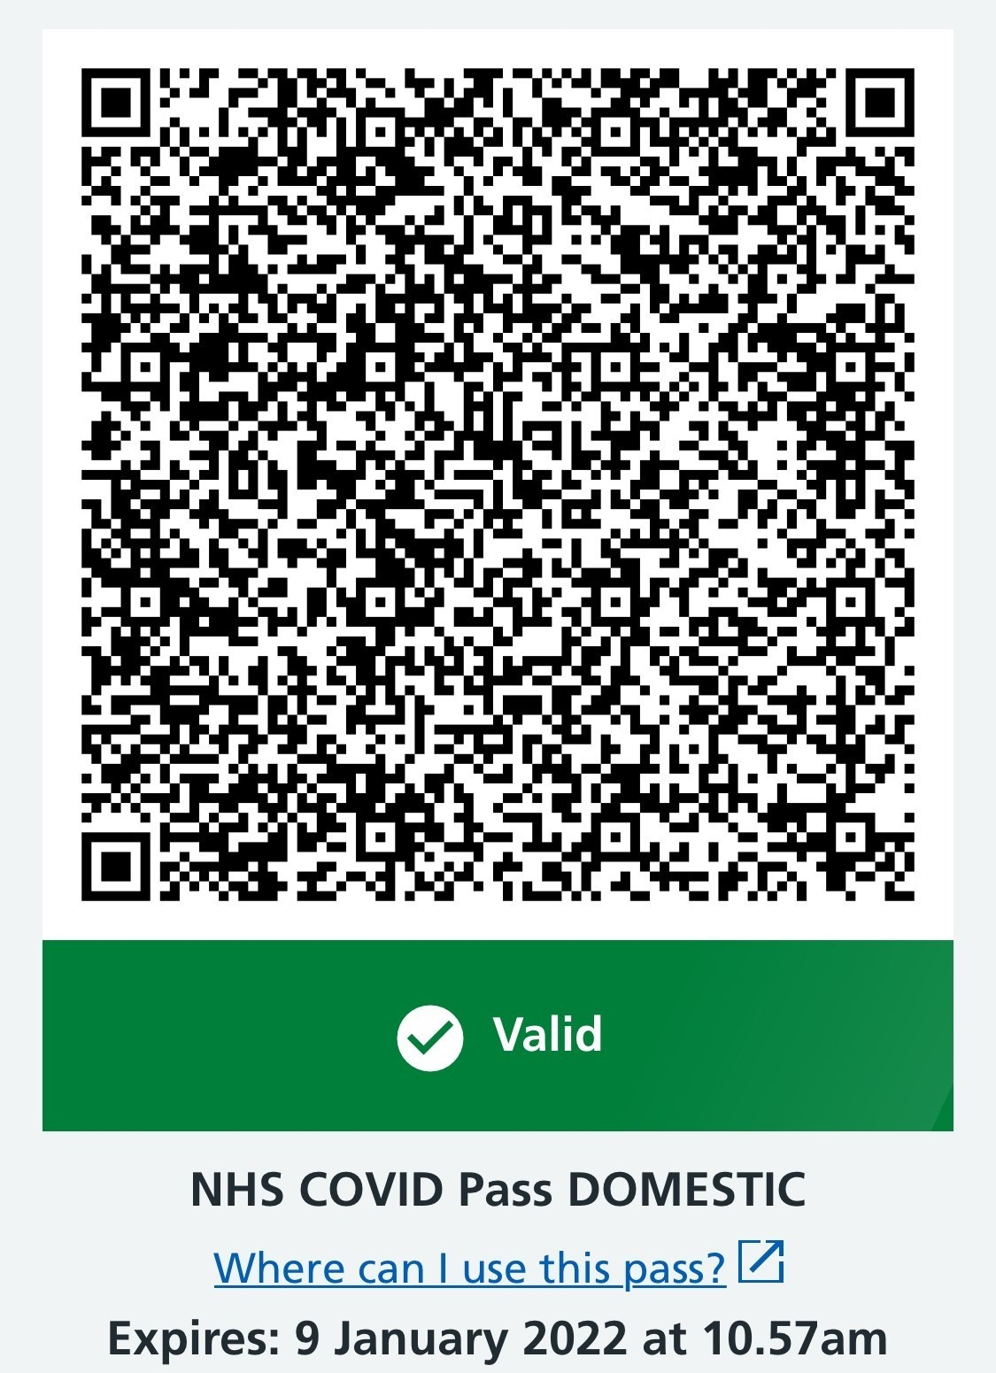

|  |  |
| --- | --- |
| Intro | More Info  **Places that legally need to check your covid pass:**   * Nightclubs * Indoor unseated with 500+ people * Outdoor unseated with 4,000+ people   + Any venue with 10,000+ people |
| Due to the Global spread of coronavirus, restrictions of travelling and movement of people have been enacted. The virus hit the UK in February  2020. People were told not to leave their own homes. Now it’s January 2022, the UK has gone through multiple lockdowns, outbreaks, new strands of the virus, and now several accessible vaccines and boosters to protect you. The severity of this virus is still high, however movement and travelling bans are being uplifted. The discussion of how to allow to uplift the bans but still try  and keep the spread of the virus at a minimal have began. A Covid pass is now given to you if you are vaccinated to a certain standard. This pass could allow you entry from your local pub to a different country , while trying to decrease the spread of the virus. However, is this the right approach and should we  increase the influence of these passes? |
| **Issue**  **Violation of freedom of movement ?** | |

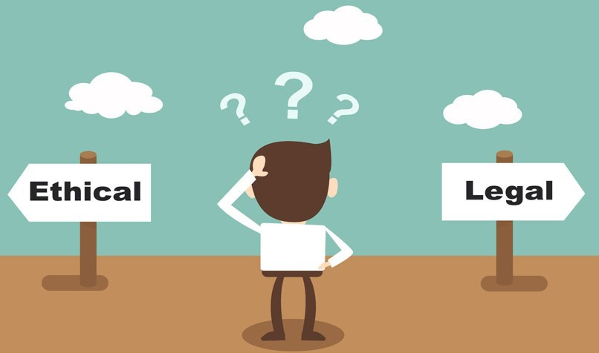SOLUTION

Hierarchy's naturally tend towards corruption. The UK government is no different, if left

unchecked it will become tyrannical. That is why we have created mechanisms in our systems to keep the corruption at a low. One of these mechanisms is to maintain a limited government,

where the power and influence of the state is kept as minimal as possible. Only to increase power through democratic ways. This is a liberal stance on how the state should be ran, and it could be argued that liberalism has guided western civilisation for the last 200-300 years. Giving the state authority to restrict movement and travel is ,in many peoples opinions, dangerous. If the state

falls corrupt and starts abusing its power, this can be a devastating weapon to supress the average person

Political stance

In the US it is protected in the Privileges and Immunities Clause of the Constitution.

While in the UK it is protected in the common law, and recently a proposition to create a

new Human Rights Act that prohibits certain restrictions. Including personal identity cards, internal passports, citizenship licenses…. Can vaccine passports be classed under these?

Freedom of movement and travel is

considered a human right by many. And many feel this right is being violated by restrictions put in place due to the global pandemic. At

the start of the pandemic People were restricted to leave their local town, city or village. Government owned buildings and

areas can deny you access if you do not have a valid covid pass. Some declare this is unfair discrimination. However when it comes to

privately owned businesses, there is a tolerance when they commit to the same restrictions. So if a local pub or sole trader

who runs a small shops decides a valid covid pass is required for entrance / their service, this is seen as the right of that business to make that decision for themselves. But the UK government has made it law that

businesses MUST check for covid passes. This is damaging especially to small businesses and is seen as the government overreaching their boundaries of power

My solution to this is a simple one, no vaccine passports. The government should not gain the power to restrict peoples ability to travel and they should not force private businesses to discriminate against the vaccinated and unvaccinated. This must remain a personal decision to the citizens and businesses. They must be made aware of the risks, and then allowed to make the choice. Although this virus is dangerous, vaccines must be encouraged at all times and keeping people aware of the risks, the state gaining power through this crisis is a far greater risk of tyranny. Bringing far greater death and destruction

**References**

* BBC News (12th September 2021), England vaccine passport plans ditched, Sajid Javid says [online]. Available from: https://[www.bbc.co.uk/news/uk-](http://www.bbc.co.uk/news/uk-)

58535258 [accessed 1/1/22]

* BBC News (5th January 2022), Covid passports: Where do I need a pass and how do I get one? [online]. Available from: http[s://www.bbc.co.uk/news/explainers-](http://www.bbc.co.uk/news/explainers-) 55718553 [accessed 6/1/22]
* Wikipedia, Freedom of movement [online]. Available from: https:// en.wikipedia.org/wiki/Freedom_of_movement [accessed 3/1/22]
* Wikipedia, Universal Declaration of Human Rights [online]. Available from: https://en.wikipedia.org/wiki/Universal_Declaration_of_Human_Rights [accessed 3/1/22]
* Quora, Why do we need a vaccine passport? [online]. Available from: https:// [www.quora.com/Why-do-we-need-a-vaccine-passport](http://www.quora.com/Why-do-we-need-a-vaccine-passport) [accessed 2/1/22]
* NHS website, NHS COVID Pass [online]. Available from http[s://www.nhs.uk/](http://www.nhs.uk/) conditions/coronavirus-covid-19/covid-pass/ [accessed 4/1/22]
* Institute for Government (20th December 2021), Covid passports [online].

Available from: http[s://www.instituteforgovernment.org.uk/explainers/vaccine-](http://www.instituteforgovernment.org.uk/explainers/vaccine-) passports [accessed 5/1/22]